

**Anti-Social**

**Disasters**

**Faculty of computers and Artificial Intelligence**

**University Of Sadat City**

Anti-Social

Disasters

Supervised By

TA. Gomaa El Mokhtar

**Prepared By**

Mohamed Ashraf Youssef Salama

Mohamed Gweily Sara Samir

**I. Present and Justify a Problem and Solution Requirements**

**Table of Contents**

A. Abstract

B. Problem to be solved

**II. Generating and Defending a Solution**

A. System Request

B. Feasibility Study

**III. Constructing and Testing the application**

1. Function Decomposition Diagram
2. Use Cases
3. Data Flow Diagram
4. Context Diagram
5. Entity Relationship Diagram

**IV. Evaluation, Reflection, Recommendations**

A. Discussion and conclusion

B. Recommendations

C. Applications

*Abstract*

**Government Complaints and Suggestions System:**

We are making a system project that allows citizens to submit their complaints and issues in an easy and perfect manner to the competent organizations.

It Facilitates direct communication between citizens and officials and people who concerns, without going through many routine processes and complex techniques that may prolong the time to solve the problem.

**The system consists of two main parts.**

**first part:**

This part is responsible for complaints and suggestions.

The complaints will be submitted through a website or mobile application.

The complaint will be submitted by filling in some required data that will be specified by selecting the organization to which the complaint is going to be submitted.

**second part:**

System administrators communicate with the person to obtain additional information about the problem to reach the best possible solution.

The problem will be presented to all organizations specialized in providing services related to these problems.

The deadline will be determined based on the problem.

Every organization should send the time required to solve the problem and the cost.

If the solution to the problem will take more time than the specified date every organization must send the reasons of delay.

After that, the system administrator deals with this organization or chose another organization, then selecting the best offer.

**The system will send to the complainant**:

* The name of the organization that was chosen to solve the problem.
* the deadline for solving this problem.
* A thanking word for her/his efforts and other data that may be required.

*Problem to be solved*

Concerning to the wide spread of the applications related to this project and the huge number of problems that needed to be handled using this application, we are choosing one type of problems to work on at a start.

Problems or complaints that specifies to the campus or the college society.

Especially in this application, we turn our attention to University of Sadat City at Faculty of Computers and Artificial Intelligence FCAI-USC.

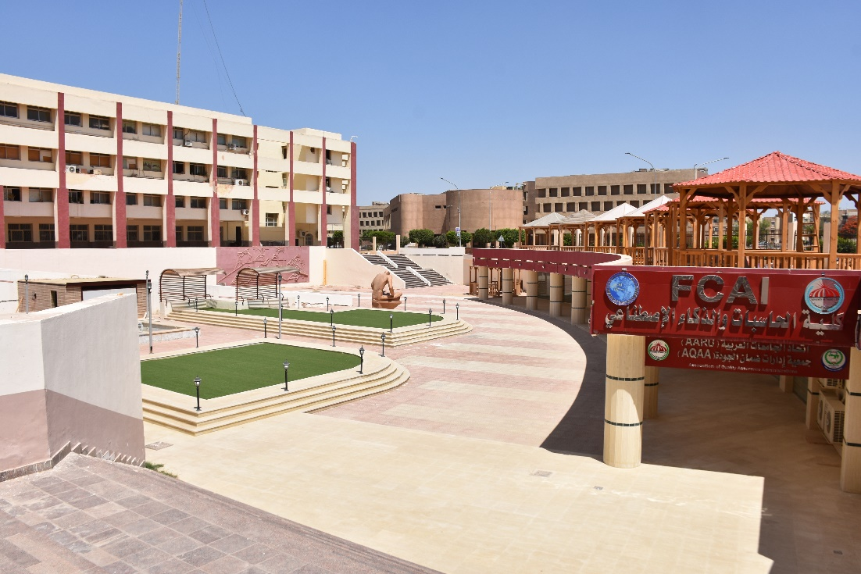

* By making a website that receive complaints from all people inside the organizations (students, professors, workers, and others) about any problems that they found related to the collage such as (complaints about professors and students, exams, cleanliness, lack of commitment, some facilities close, ……)
* Everyone has its own profile with the ability to hide his/her personality when complaining (only the admin will know it)
* Posts will be only published after the administrator’s permission.

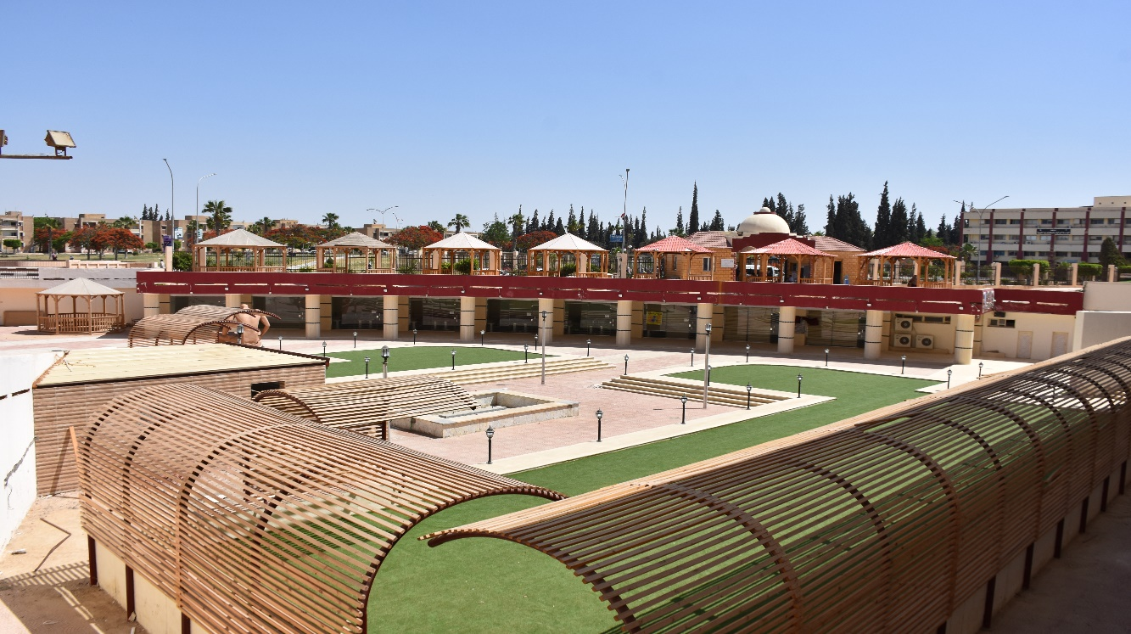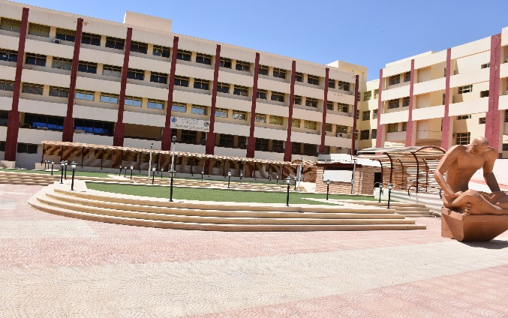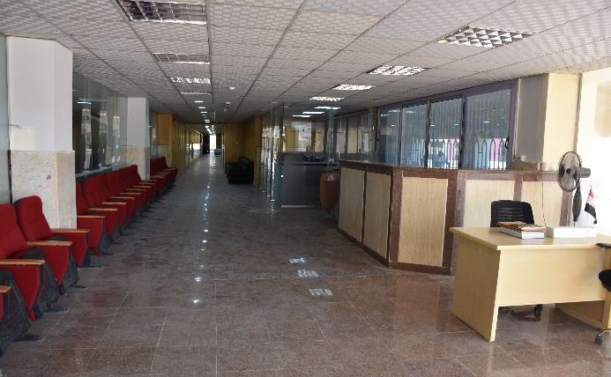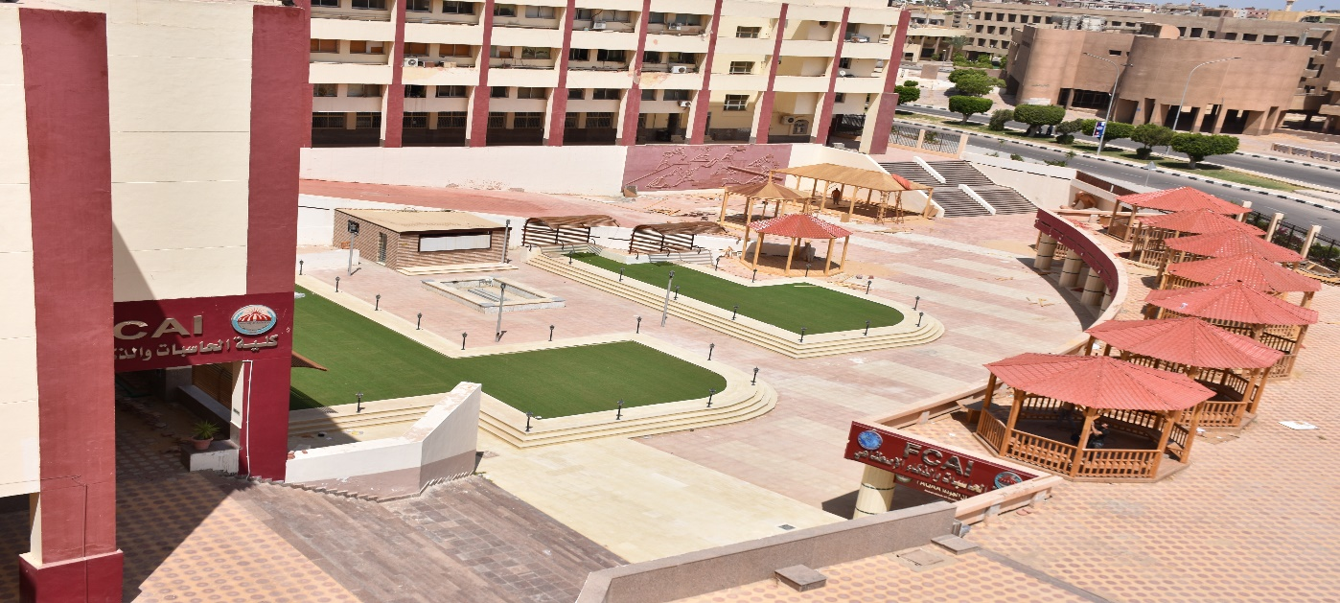

*System Request*

**Project name:** Anti-social Disasters

**Sponsor:** Team, The government, target organizations and ministries.

**System needs:**

* providing easier and faster way for solving problems by complaining about them online and contacting directly with the complaints center.
* good internet network, server, and computer devices founded in the complaints center that specified for our application organization.
* searching for the intended organizations, workers on it and equipment they need and provide it.
* money.
* Location locator (such as using google map)
* Vehicles

**System requirements (functionality)**

* Receive photo or evidence of the problem (user can add it)
* Make voice records and comments.
* user can add or delete his post.
* add some posts to favorite to be easy to reach.
* The ability of sharing locations.
* Receive the customer data such as phone number and National id. (According to the log in information and the user profile)

**Expected values:**

**Intangible:**

* Reduce society problems.
* Reduce time required for solving these problems.
* huge progress for the society due to the lack of the problems.
* Good Reputation
* Citizens satisfaction
* Easier handling for society problems.

**Tangible:**

* Earning money
* More services to deal with
* Wider use of the applications due to the online service.

**Issues and Constrains:**

* huge increase in the problems that the government need to solve at the same time.
* Lake of workers, vehicles, and equipment.
* Time bounded
* Cost

*Feasibility Study*

**Feasibility Study Table:**

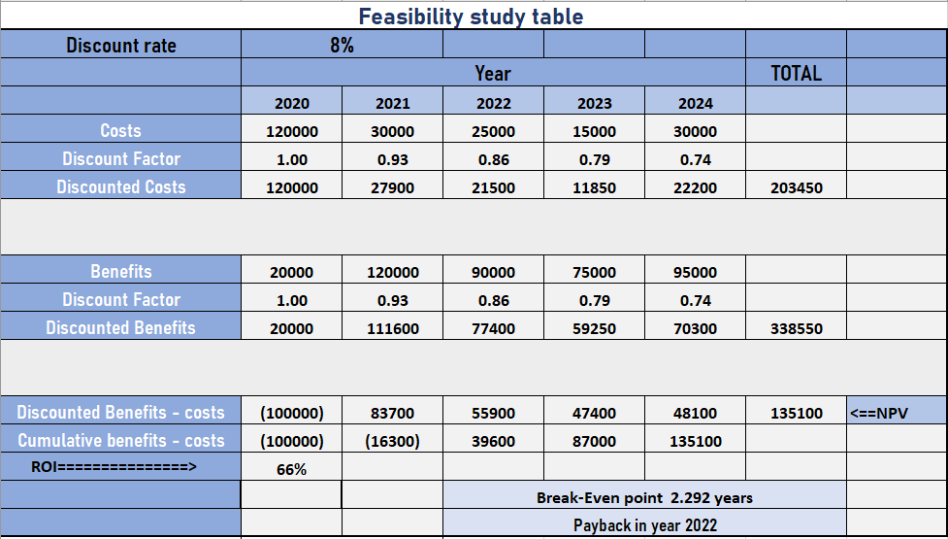

**Feasibility Analysis**

* **Operational Feasibility – People**
* this system project will adopt with the needed environment as it can work with different environments like the university of Sadat City in addition to organizations that linked to the system.
* People into the organization will be able to work with the system as it will use a very friendly user interface with a highly adaptable User Experience in addition to a familiar technology.
* The stuff will be trained under the supervision of a qualified team from the Faculty of Computers and Artificial Intelligence _ University Of Sadat City
* Users will be able to deal with the system as it is like an announcement, chatting application with a very friendly UX.
* **Technical Feasibility – Hardware and Software**
  + **Hardware:** Web Cameras, Web Microphones, Routers, Fiber Optic Cabling, Desktop computers, sever, a working sit.
  + **Software:** Video Conferencing Software, Chatting Software, recording software, Browser Software, Web Design Software.
* **Schedule Feasibility – Time**
  + 20 weeks, the total time needed to accomplish this project.
  + 12 weeks for planning, analyzing, and designing the project.
  + 8 weeks for project implementation and maintenance
* **Economic Feasibility – Money**
  + is a measure of the cost-effectiveness of a project or solution. This is often called a *cost-benefit analysis*.
  + $8.000 / 150.000 L.E to be spent on the overhaul of HW and SW and train staff in the use of the system.

*Function Decomposition Diagram*

*FDD*

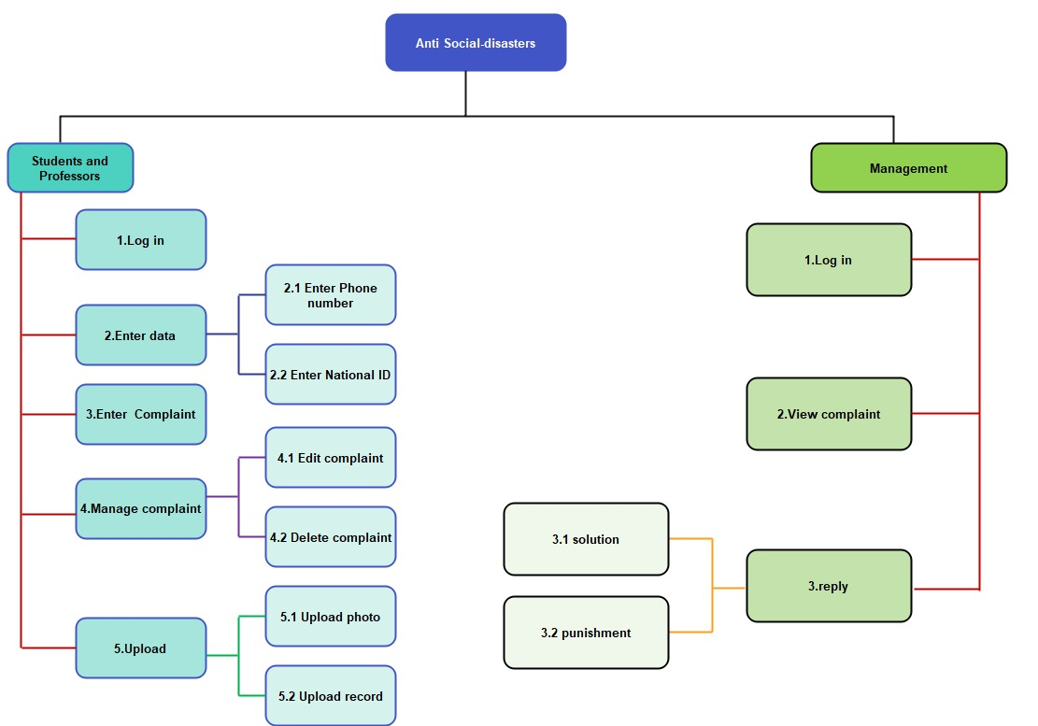

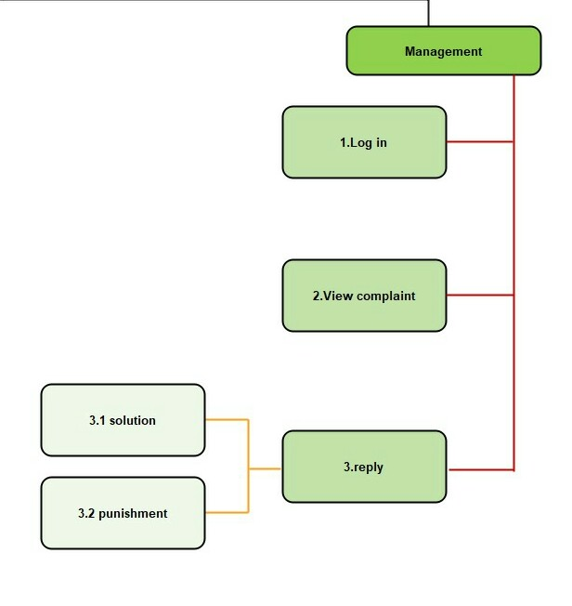

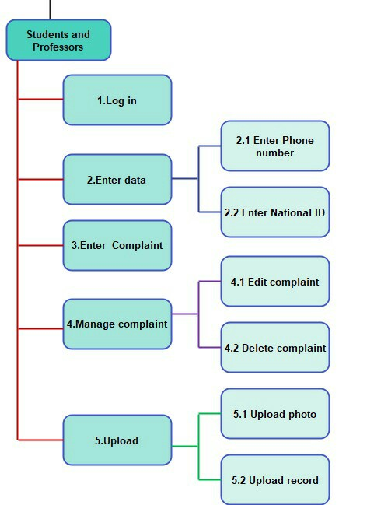

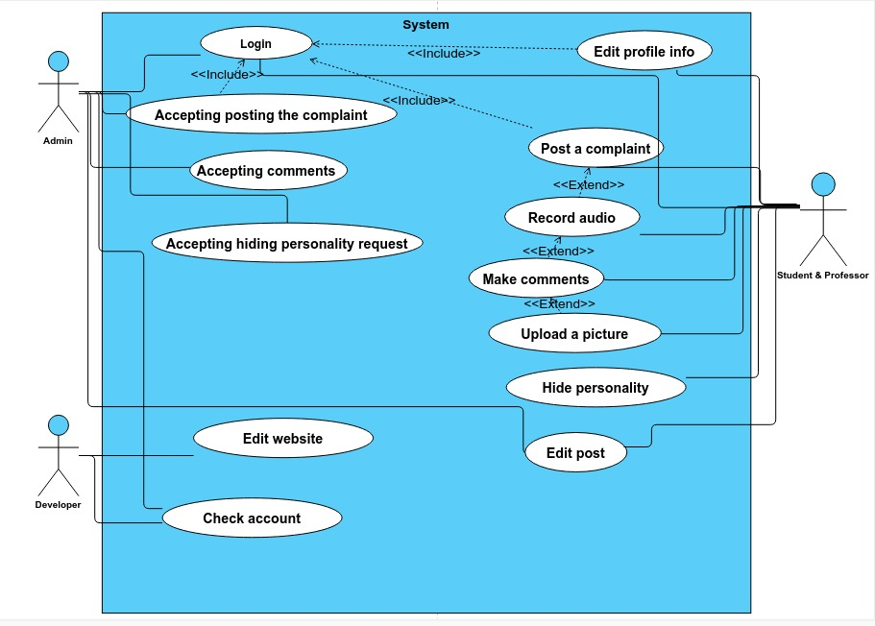*Use Case Diagram*

*Data Flow Diagrams*